SREE DATTHA INSTITUTE GROUP OF INSTITUTIONS
DEPARTMENT OF ELECTRICAL
S.NO. | FACULTY NAME | JNTUH ID | DESIGNATION | MAIL ID | PHOTOGRAPH
1 | Dr. B. Venkata Prasanth | 5891-190506-162102 | PROFESSOR  &  PRINCIPAL | bvenkataprassanth@gmail.com
2 | T.S.Vijayalakshmi | 2567-180707-120423 | ASSISTANT PROFESSOR | Nurani.vijayalakshmi@gmail.com | 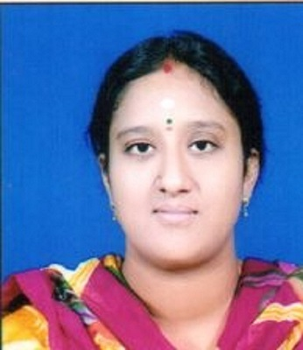
3 | G.Varuna Shree | 4835-190125-113508 | ASSISTANT PROFESSOR | gvarunashree@sreedattha.ac.in
4 | B.Linganna | 6272-170210-193157 | ASSISTANT PROFESSOR | blinganna@sreedattha.ac.in
5. | Gundepureddy Anuroopa | 7757-171108-150925 | ASSISTANT PROFESSOR | Ganuroopa321@gmail.com | 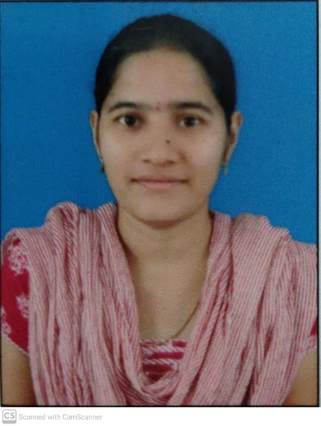
6. | Sowjanya Masna | 5912-160209-104818 | ASSISTANT PROFESSOR | masnasowjanya@gmail.com
7. | Aluri Mamatha | 8518-170103-163055 | ASSISTANT PROFESSOR | mamathachanni@gmail.com
8. | Subbamma Subbamma | 9208-171215-154514 | ASSISTANT PROFESSOR | Susheeela.sandhya@gmail.com | 